STEP 1

Login to [AWS Console](https://signin.aws.amazon.com/signin?redirect_uri=https%3A%2F%2Fconsole.aws.amazon.com%2Fconsole%2Fhome%3Fstate%3DhashArgs%2523%26isauthcode%3Dtrue&client_id=arn%3Aaws%3Aiam%3A%3A015428540659%3Auser%2Fhomepage&forceMobileApp=0&code_challenge=DQPPPPwJLFPYXZ).

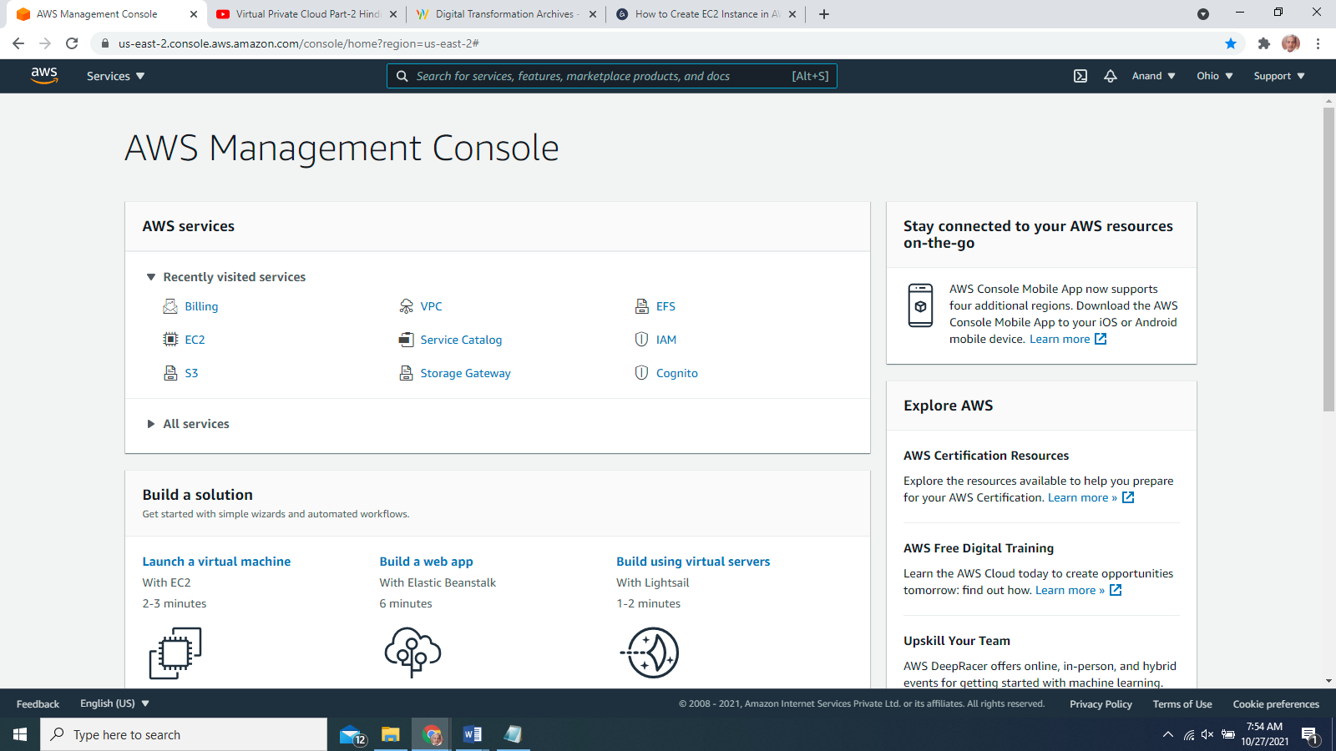

STEP 2

After login successfully, you are on the dashboard page. Select ‘Services’ from the top navigation bar and click ‘EC2’ under the category ‘Compute’.

STEP 3

On the EC2 instance dashboard page, select the data center closest to your geographical location(region)

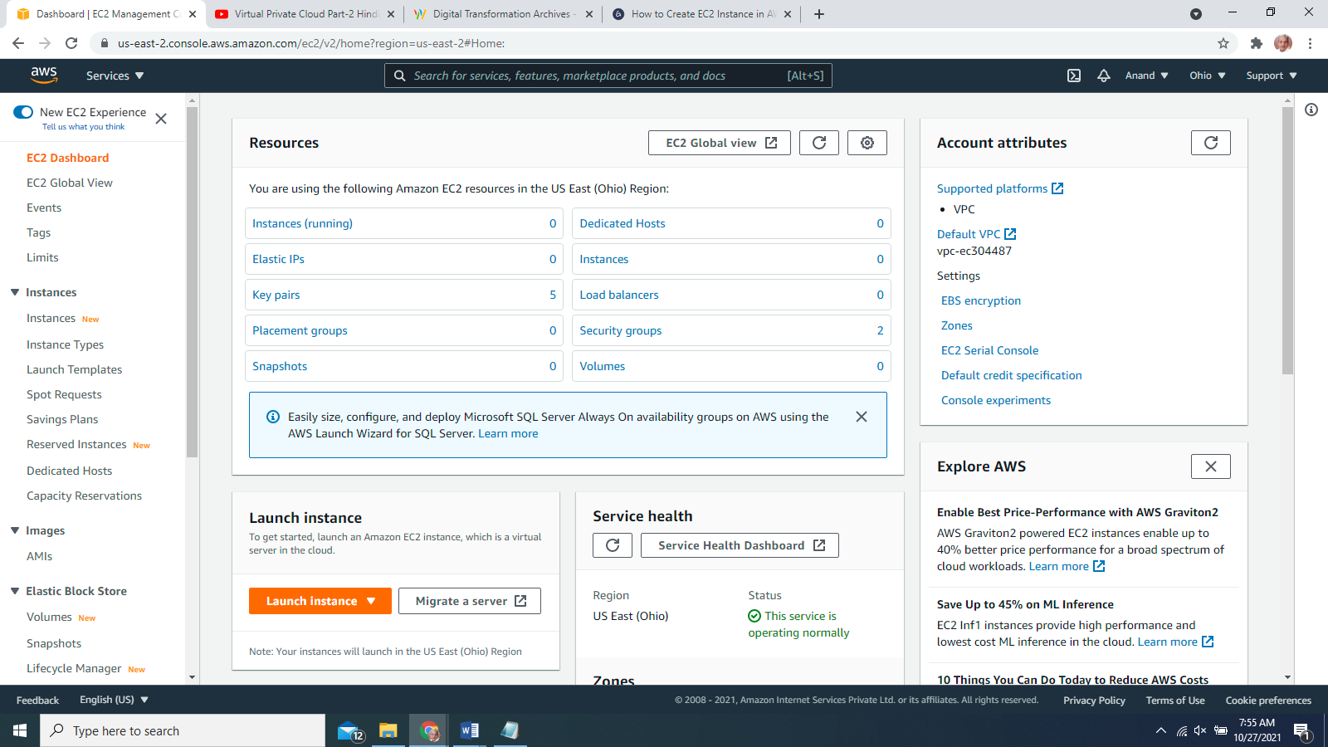

STEP 5

select your operating system for your EC2 instance. E.g., if you want to create **Windows Server** instance, on the page search, type ‘windows’ as the search option and press ‘enter’.

**STEP 6**

‘Select’ button beside the needed image. **‘Microsoft Windows Server 2019 Base’** image.

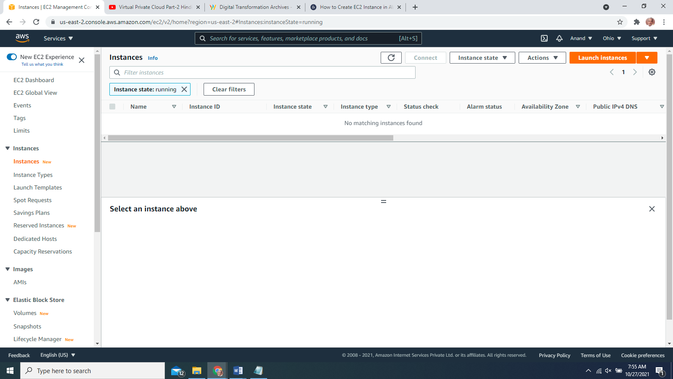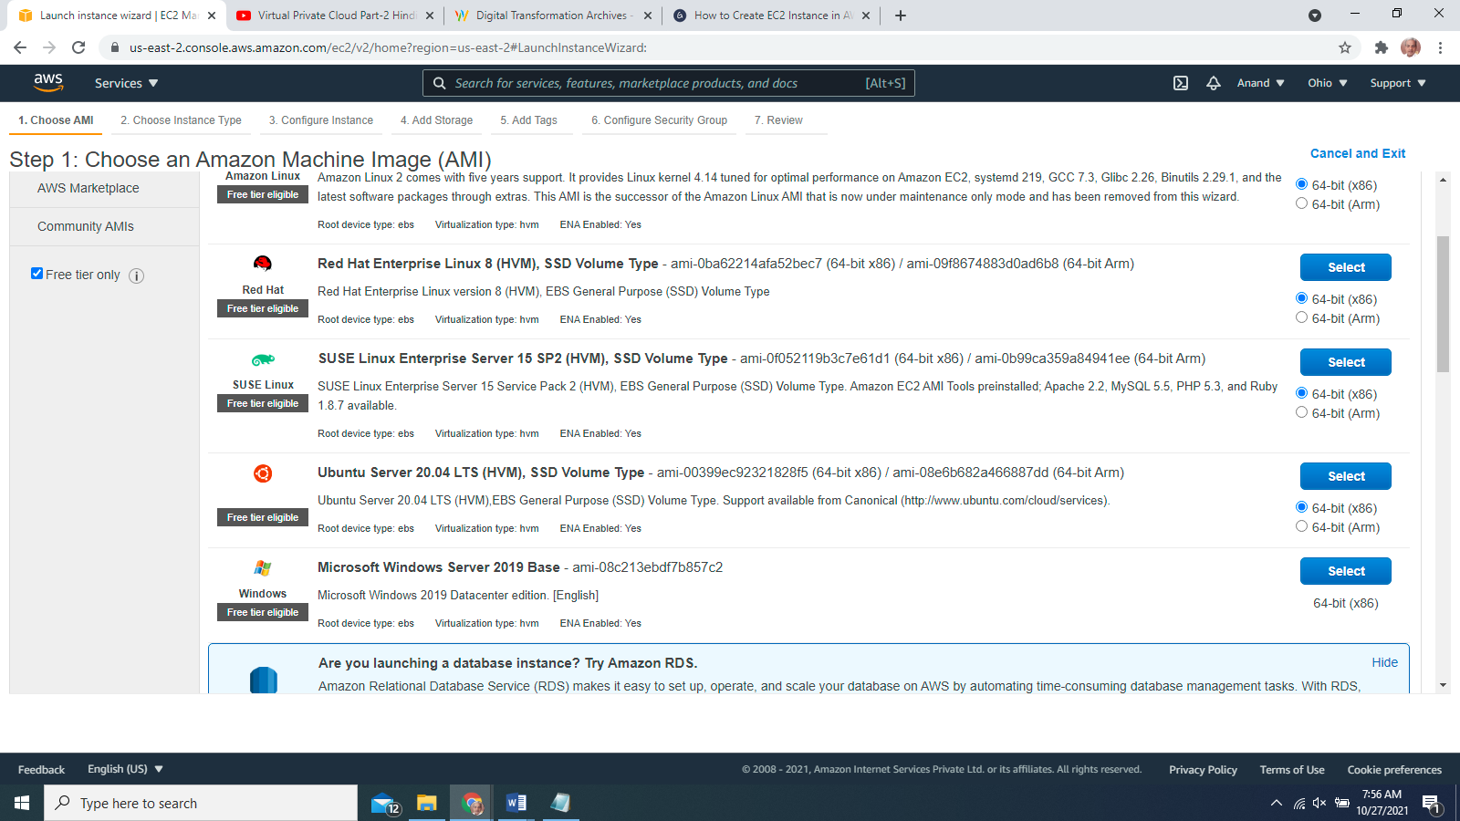

**STEP 7**

select the type of the instance based on your requirement like RAM, network performance, etc. AWS selects the default **t2.micro**(free) instance and click the ‘Next: Configure Instance Details’ button

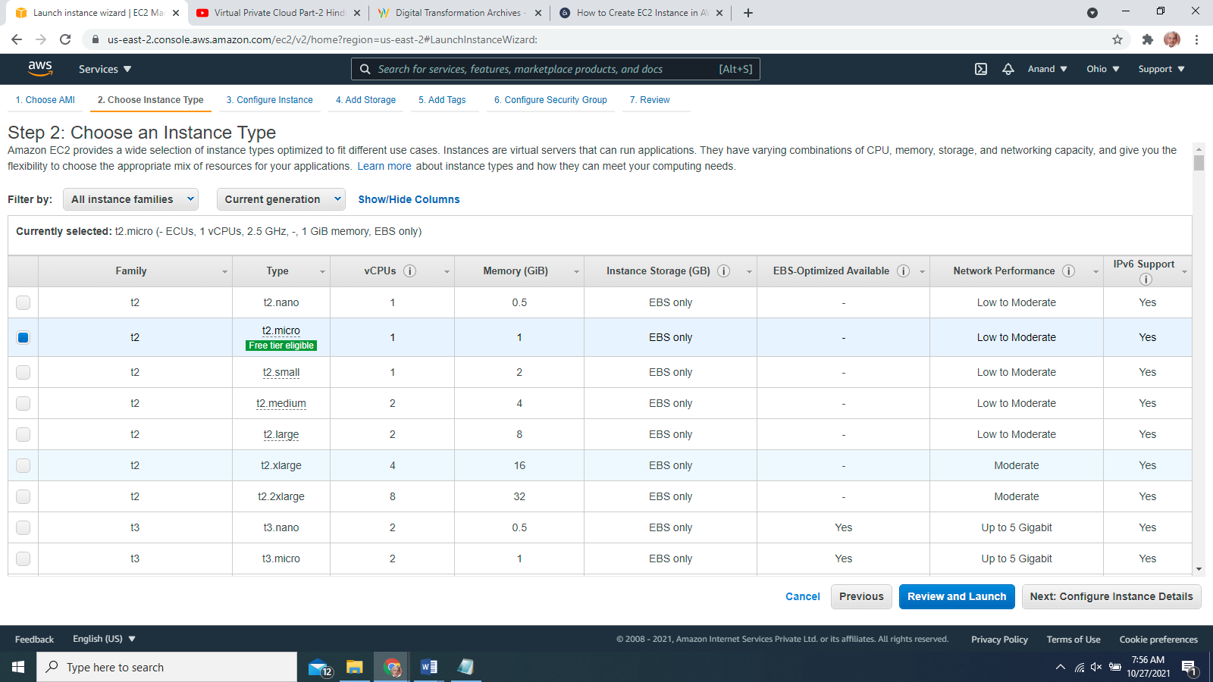

STEP 7

**Enter the number of instances in the ‘Configure Instance Details’ page. The default value is 1, and you can create multiple instances based on your need. Click on the ‘Next: Add Storage’ button.** 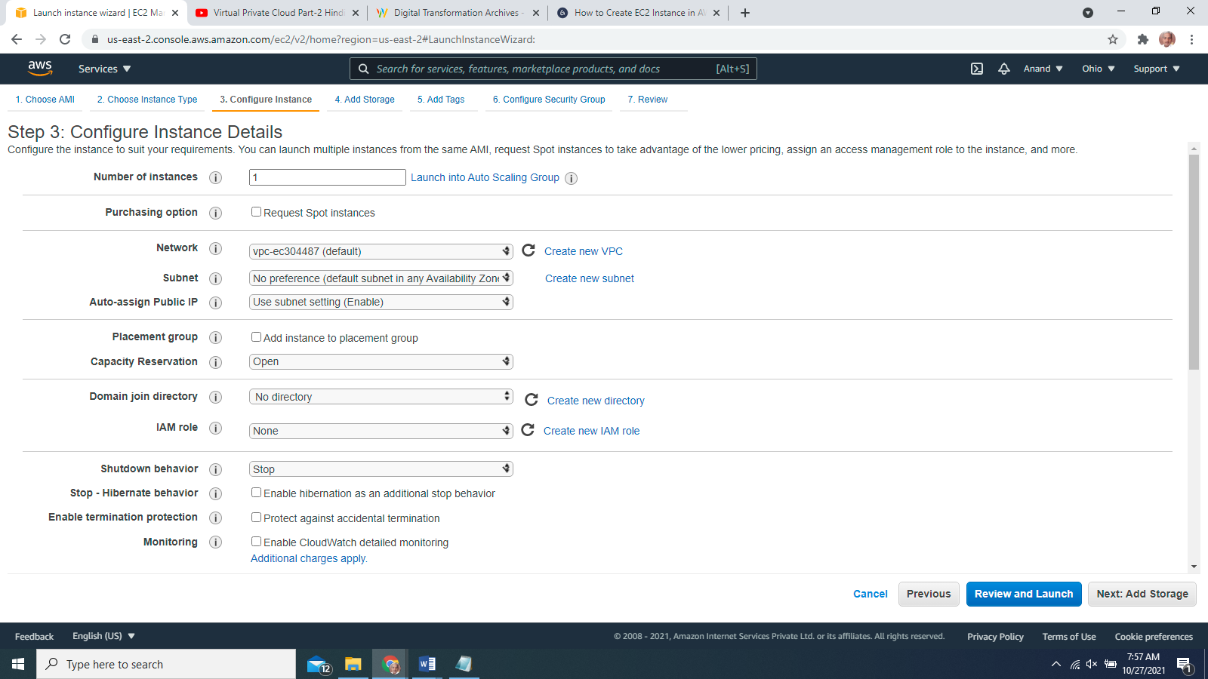

STEP 9

On the ‘Add Storage’ page, you can add a storage device for storing your files. With the Free Tier, by default, you get 30GB of storage per instance. You can buy additional storage by clicking on the ‘Add New Volume’ button. Next, click on the ‘Next: Add Tags’ button.

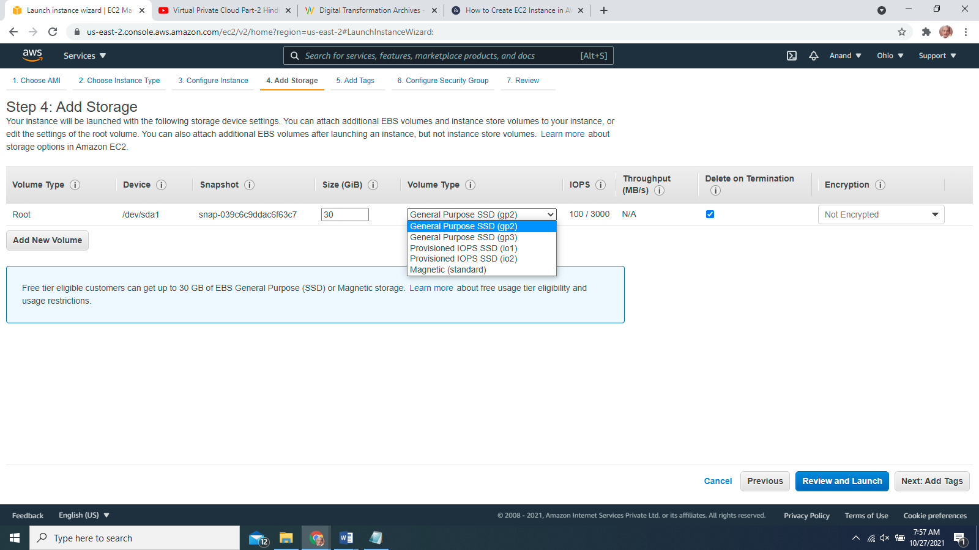

**STEP 10**

In the ‘Add Tags’ page, click the ‘Click to add the Name tag’.

**STEP 11**

In the ‘Key’ field’ type ‘Name’ and enter the values as ‘**pat-winwebserver**’. Click the ‘Next: Configure Security Group’ button.

**STEP 12**

On this page, you can choose the configuration to access this EC2 compute instance. By default, you choose the windows image and its automatically defined RDP connection. By default, ‘Custom’ is selected in the ‘Source’ dropdown. You can change it to ‘Anywhere’ to allow any IP address to access your instance. Alternatively, you can select ‘My IP’, which will restrict its access to your IP or keep ‘Custom’ which will allow you to specify the IP address range that can access your EC2 instance. Now, click the ‘Review and Launch’ button.

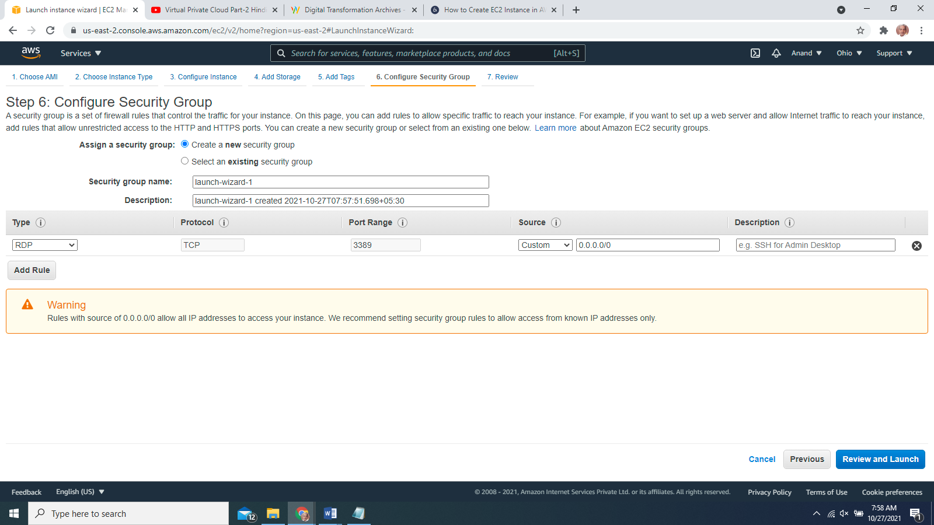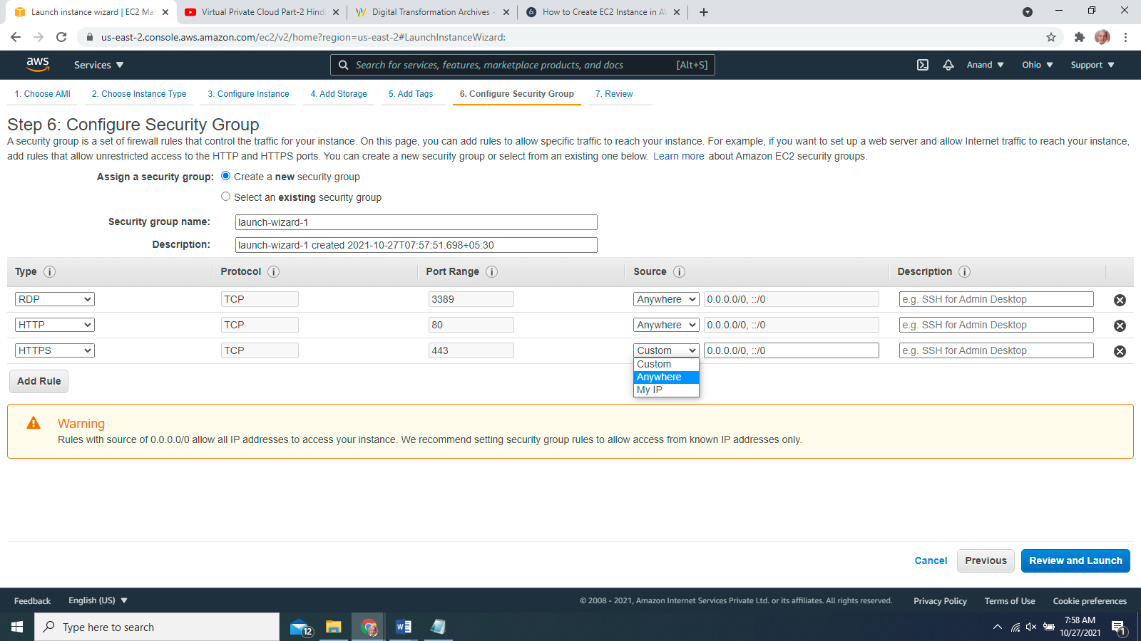

**STEP 13**

On this page, review all of your selected configurations and click the ‘Launch’ button.

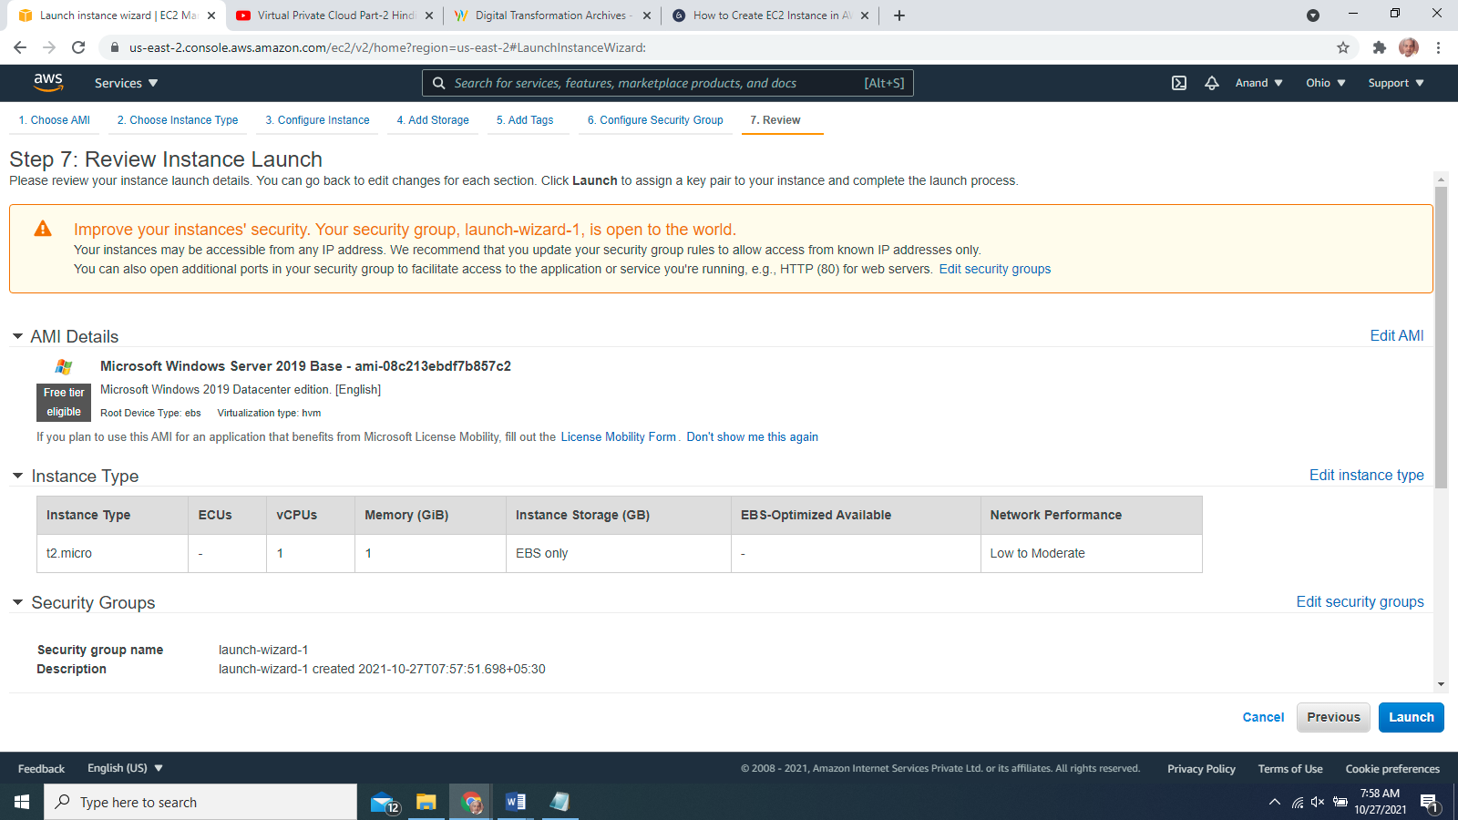

**STEP 14**

A ‘Key Pair’ window is prompted. Select the ‘Create a new key pair’ option from the dropdown, and in the next text field, type a unique key pair name. Click the ‘Download Key Pair’ button. It will download the key pair file with ‘**patnawebserverkp.pem**’ extension on your computer. It’s crucial for generating unique passwords for the EC2 instance.

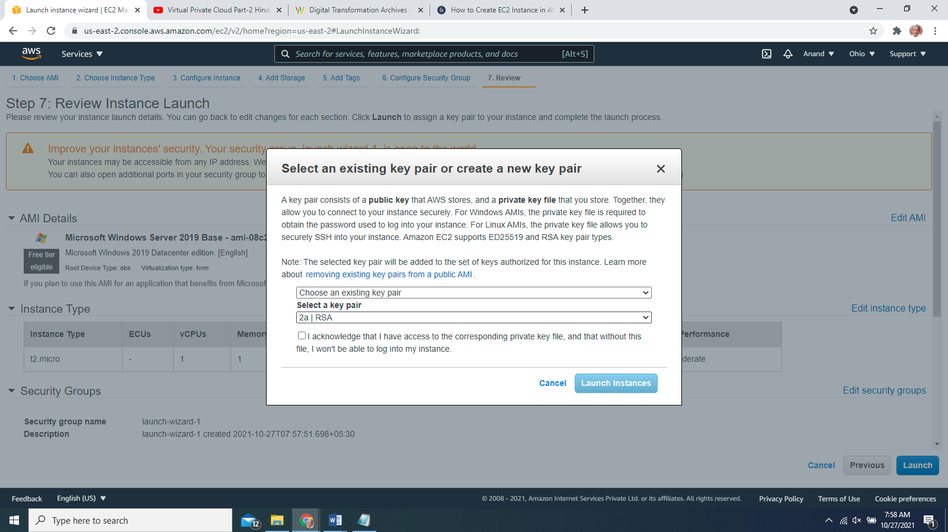

**STEP 15**

Click the ‘Launch Instances’ button, and it’s directed to the launch status page.

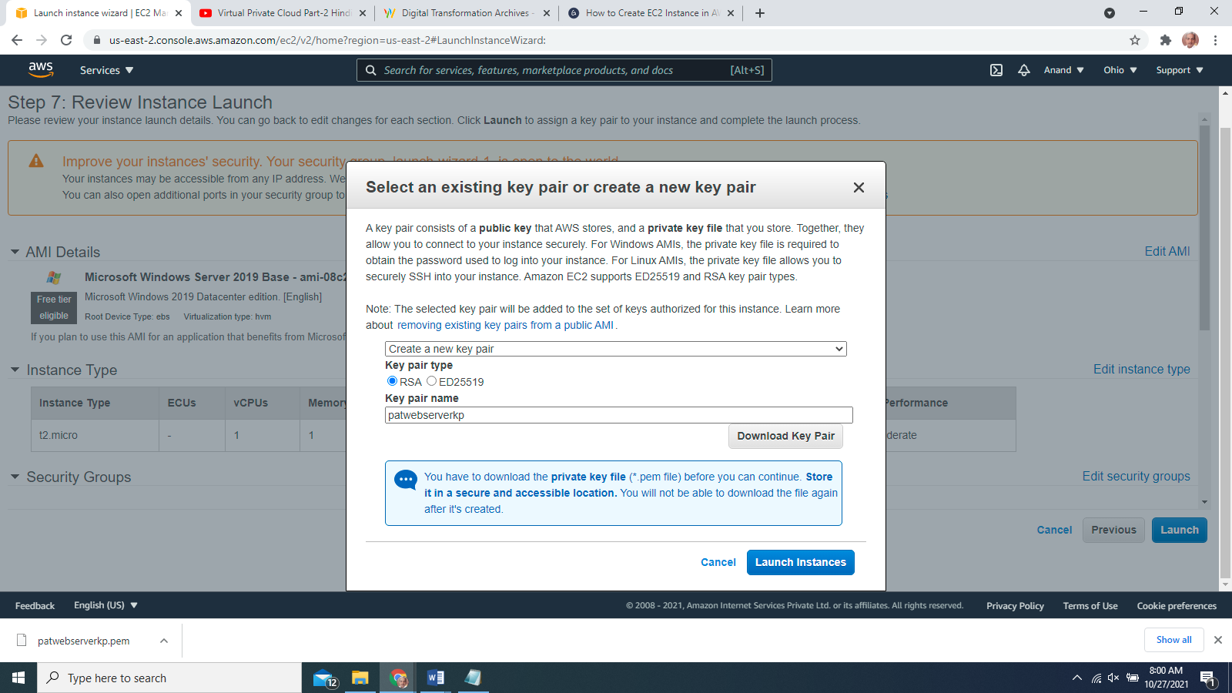

STEP 16

The ‘Launch Status’ page is displayed.

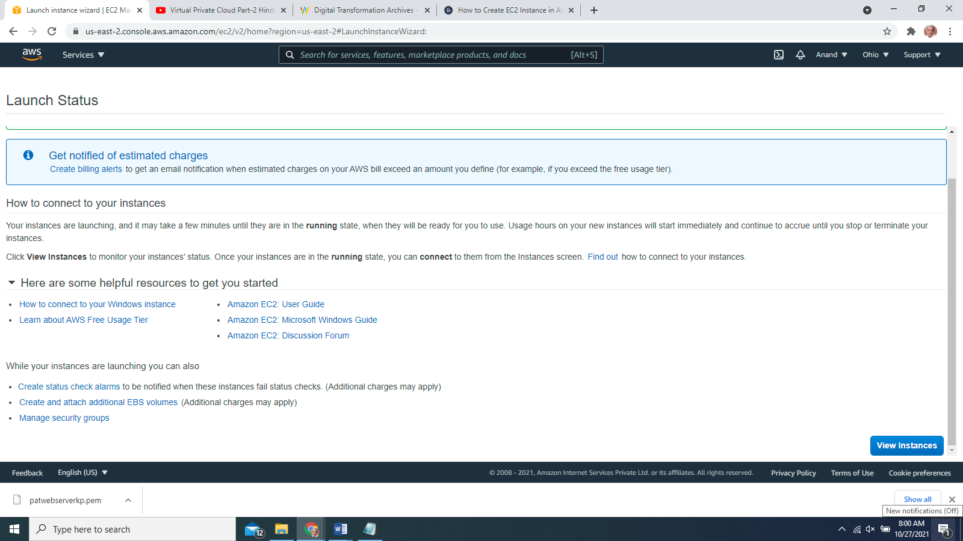

**STEP 17**

Scroll down the page and click on the ‘View Instances’ button.

**STEP 18**

All the available instances are displayed. The following image shows that the ‘**pat-winwebserver**’ instance

**STEP 19**

The new instance is shown running in the list of instances.

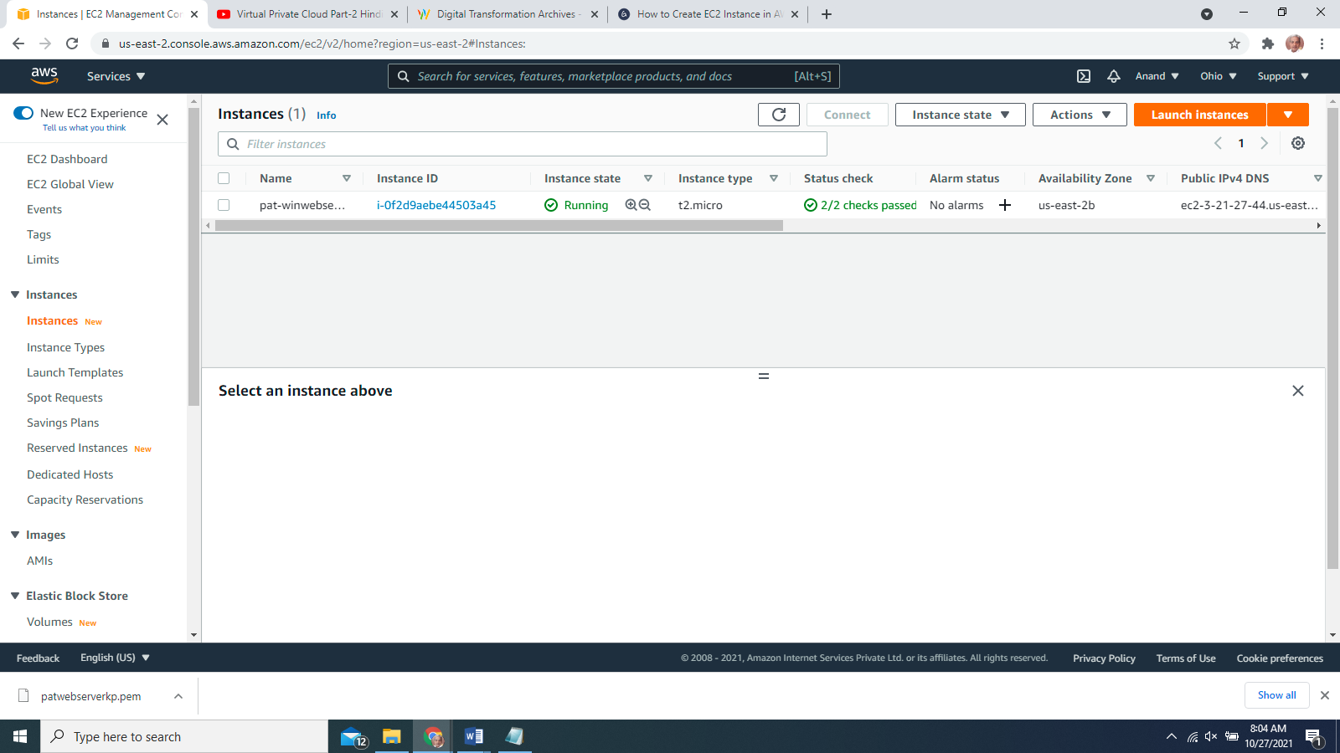

**STEP 20**

Select the newly created instance (‘**pat-winwebserver**’ in this case) and click on the ‘Connect’ button.

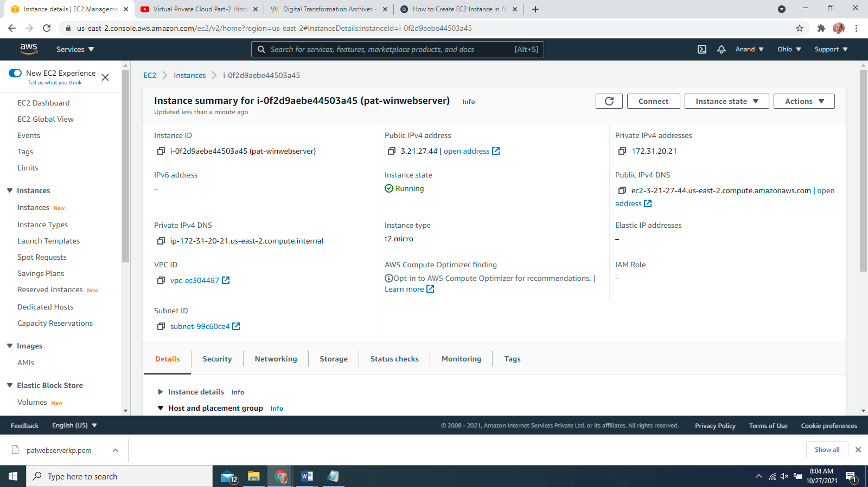

Download RDP File

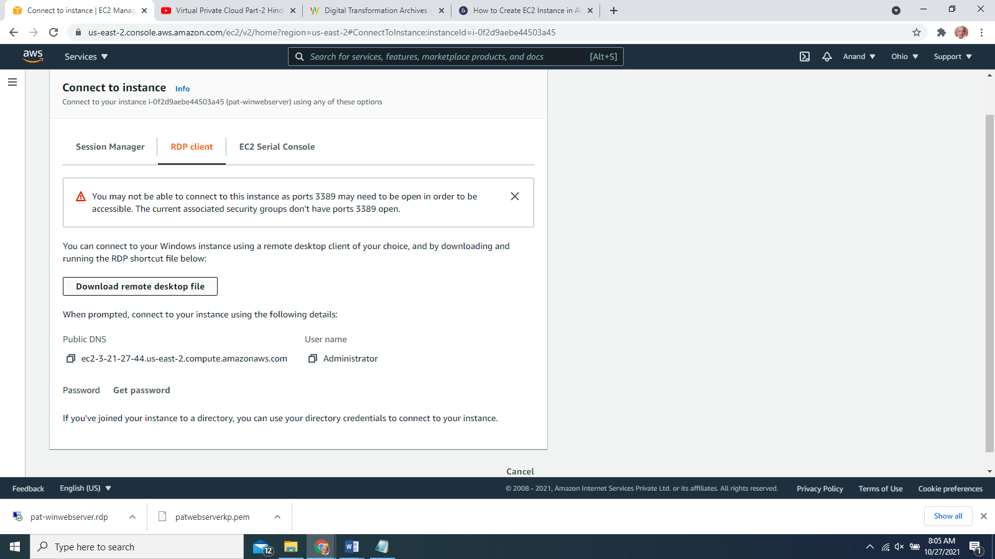

STEP 22

Click the ‘Get Password’ button.

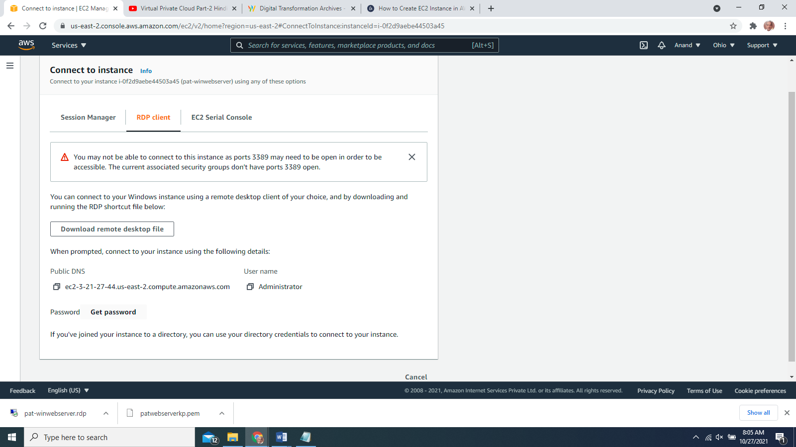

**STEP 23**

Click on the ‘Choose File’ button and select the already downloaded **patwebserverkp.pem** pair file. Click on the ‘Decrypt Password’ button.

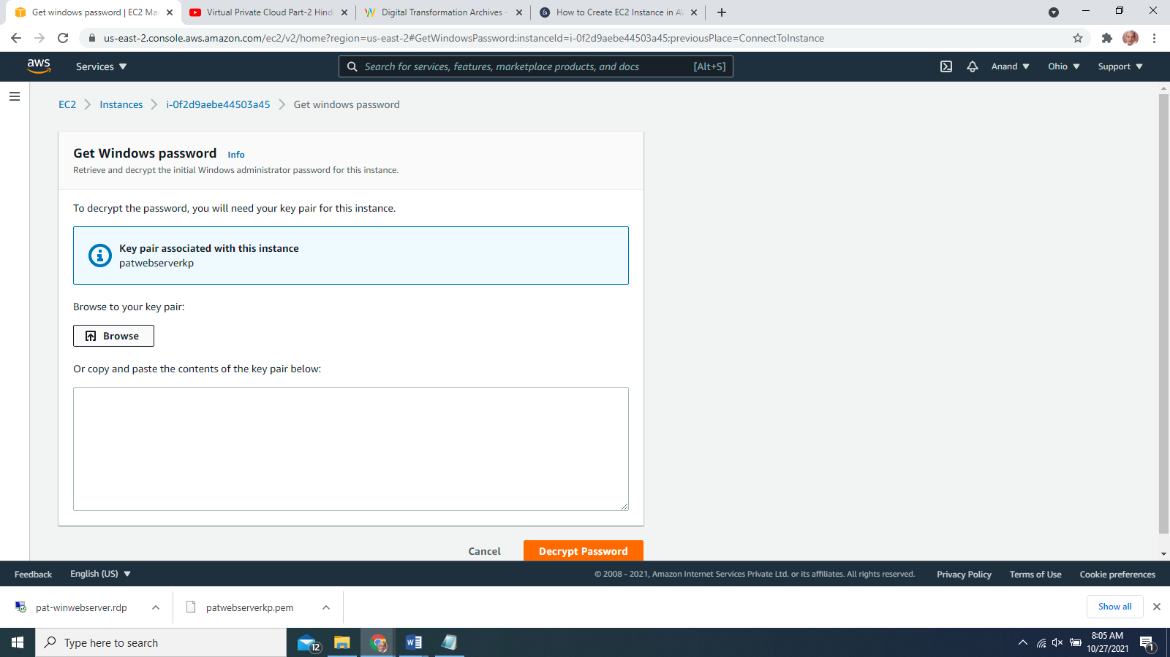

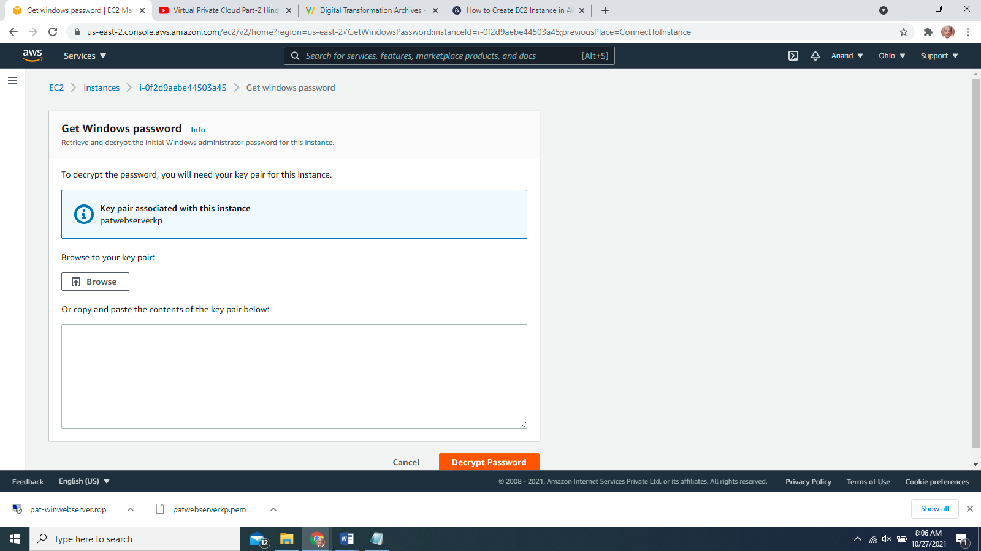

**STEP 24**

The decrypted password will appear. Copy the Password and paste in any word processor file. Click the ‘Close’ button.

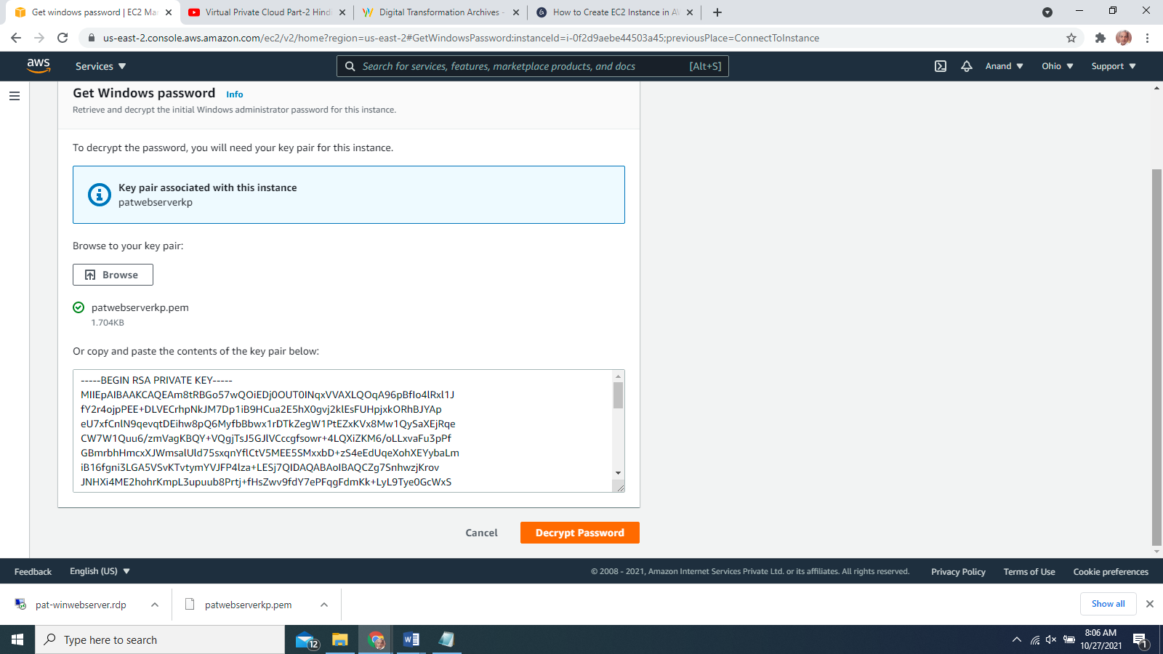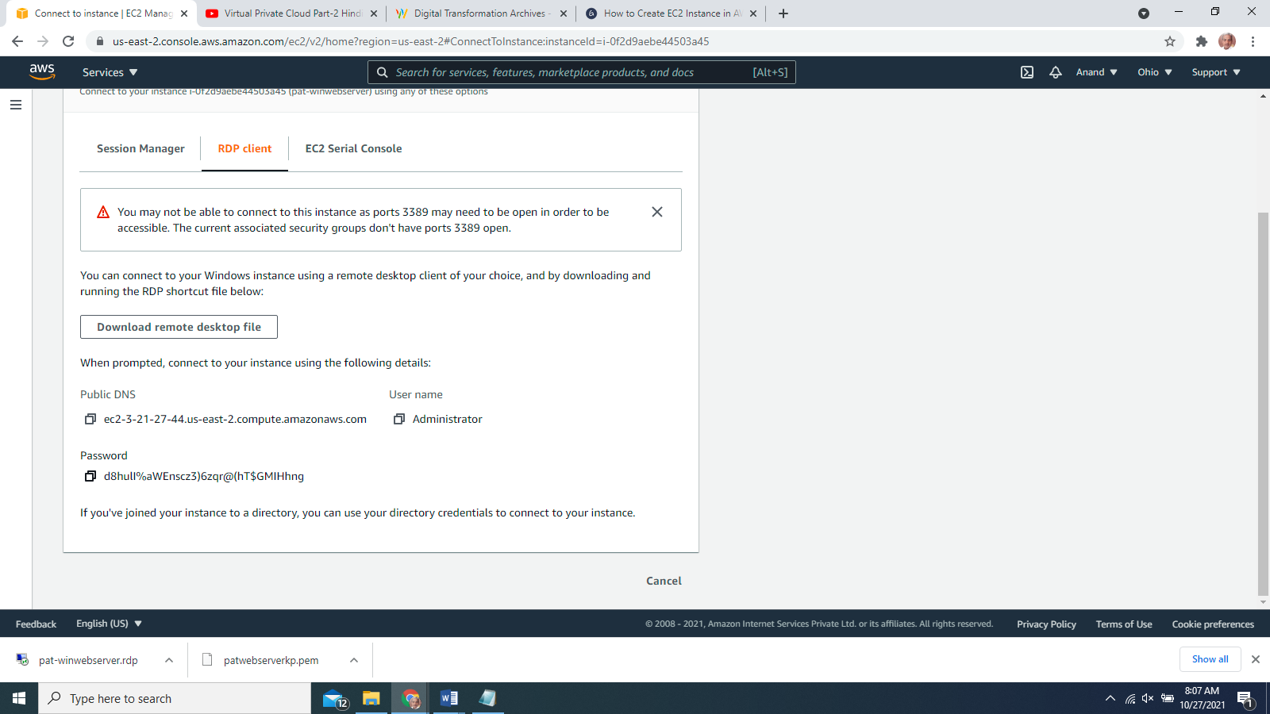

**STEP 25**

Now, go to your downloaded RDP file. The RDP software prompts to connect with EC2 instance. Click the ‘Connect’ button. In the popped up ‘Windows Login’ window, paste the previously copied password from the AWS console and click the ‘OK’ button. It will start to establish connections with the AWS EC2 instance.

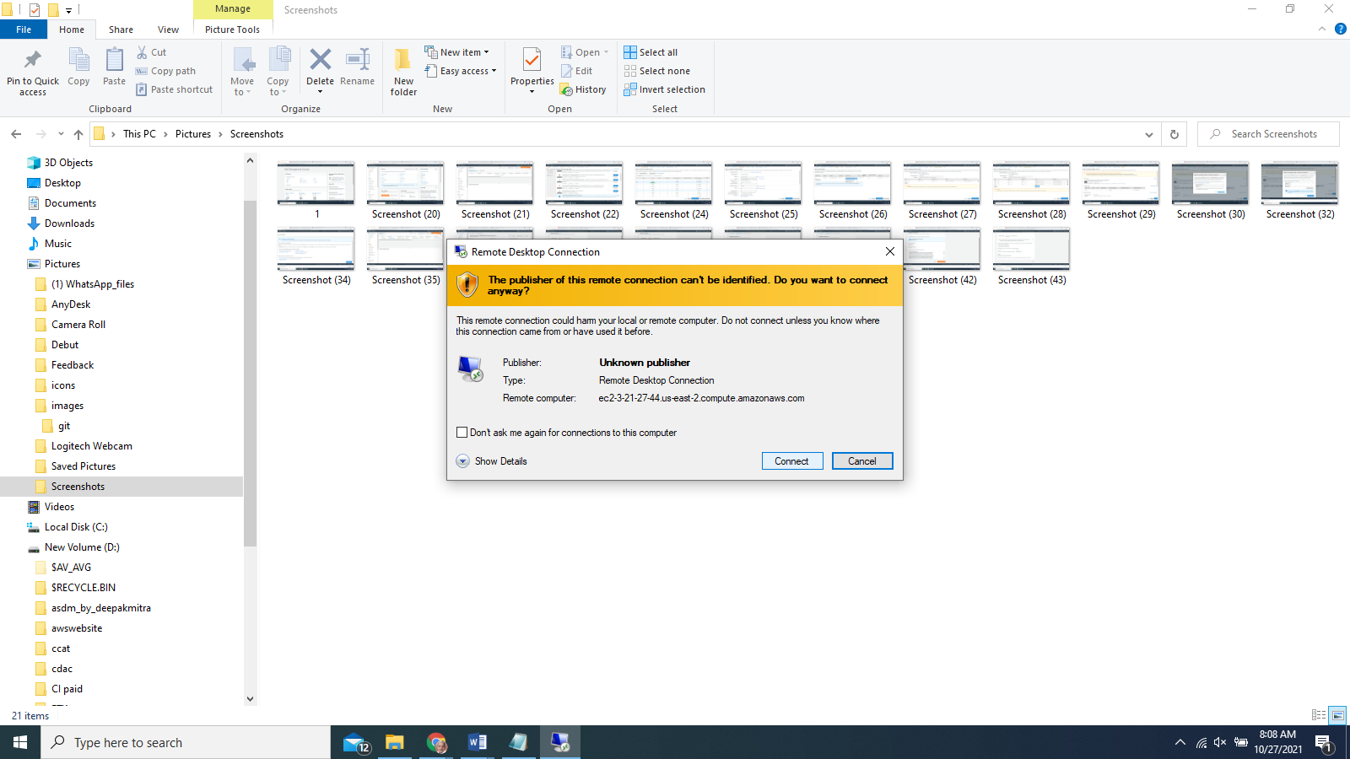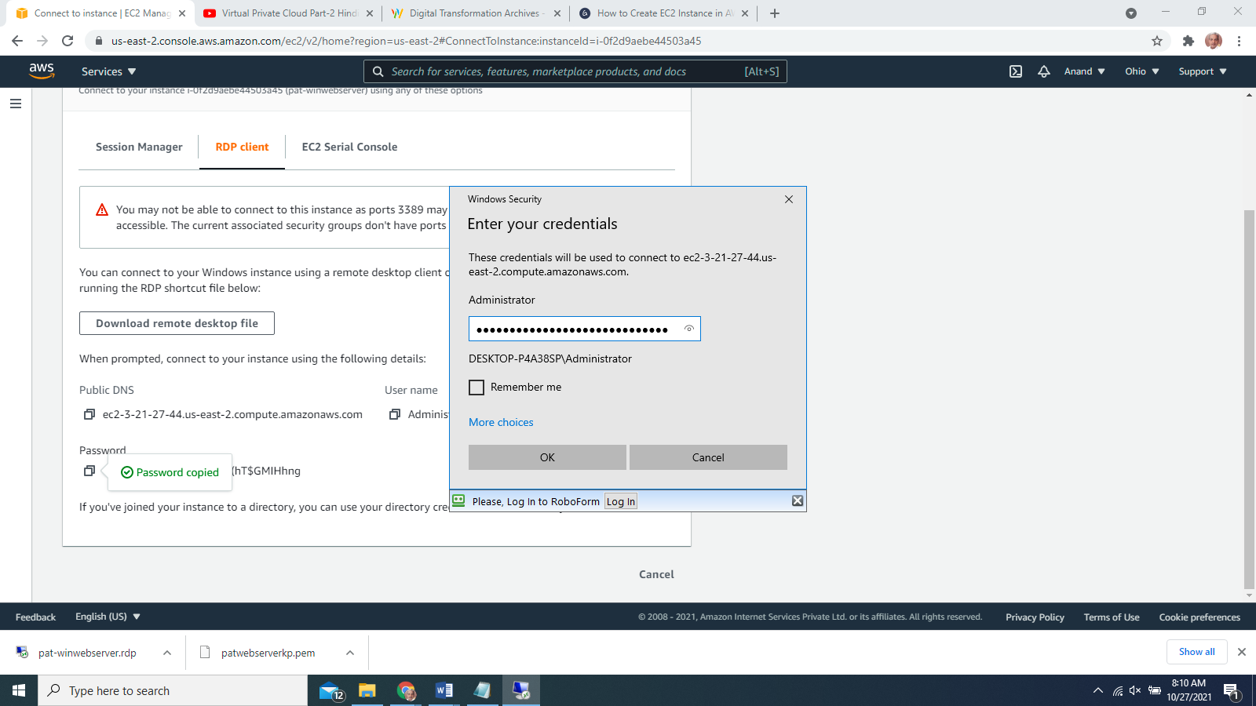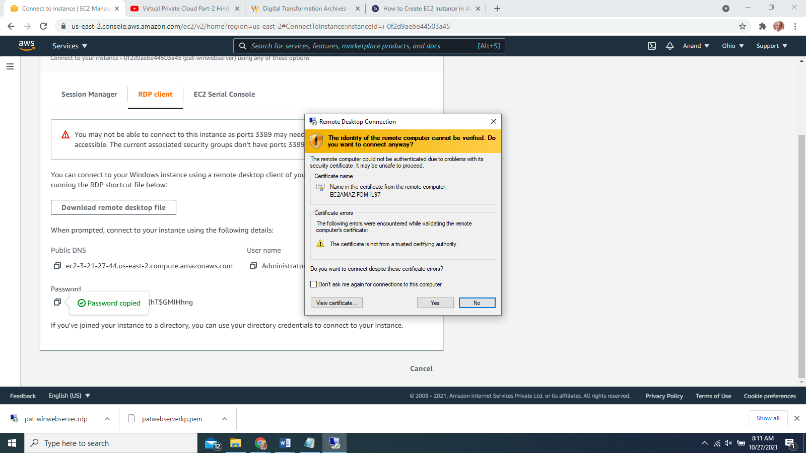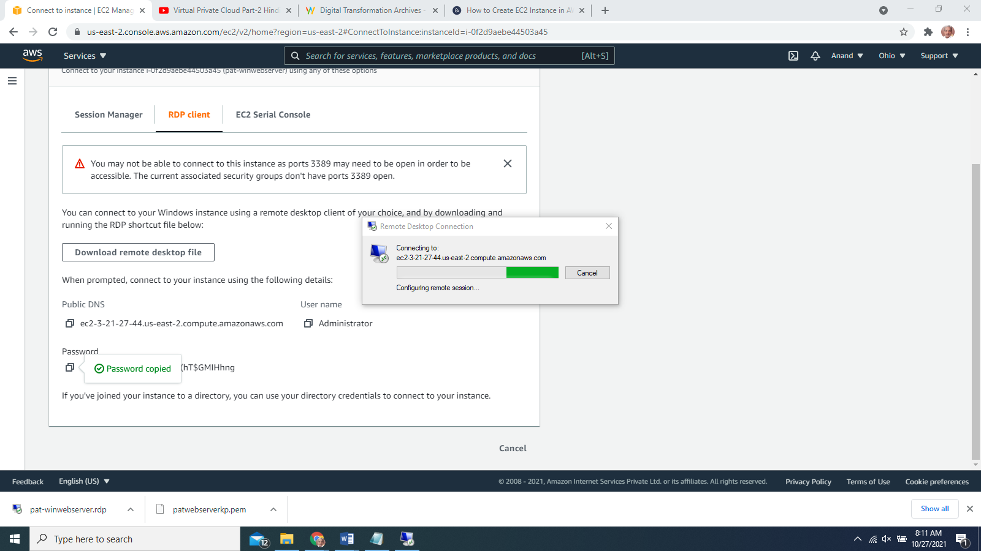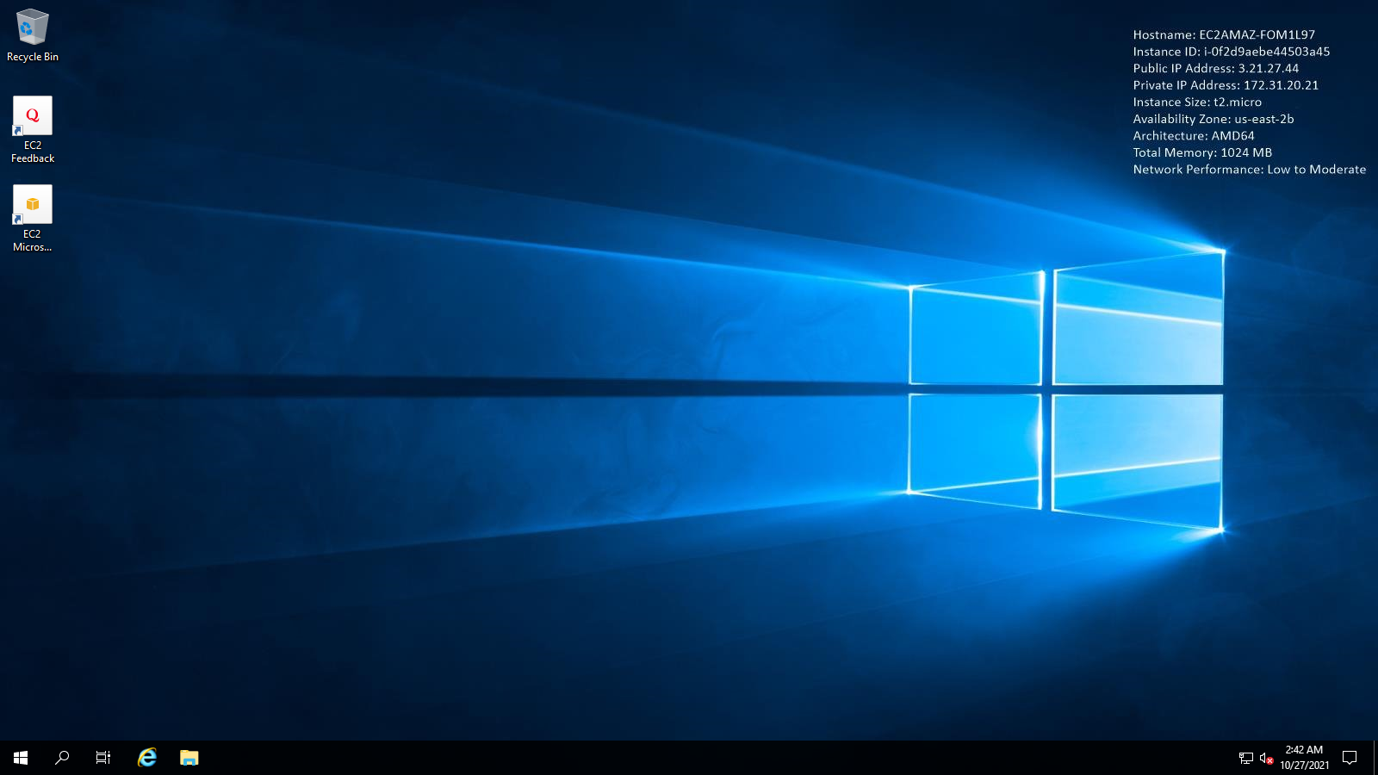

**Creating a Web Server IIS**

Login to win 2019 server.

Select Server Manager

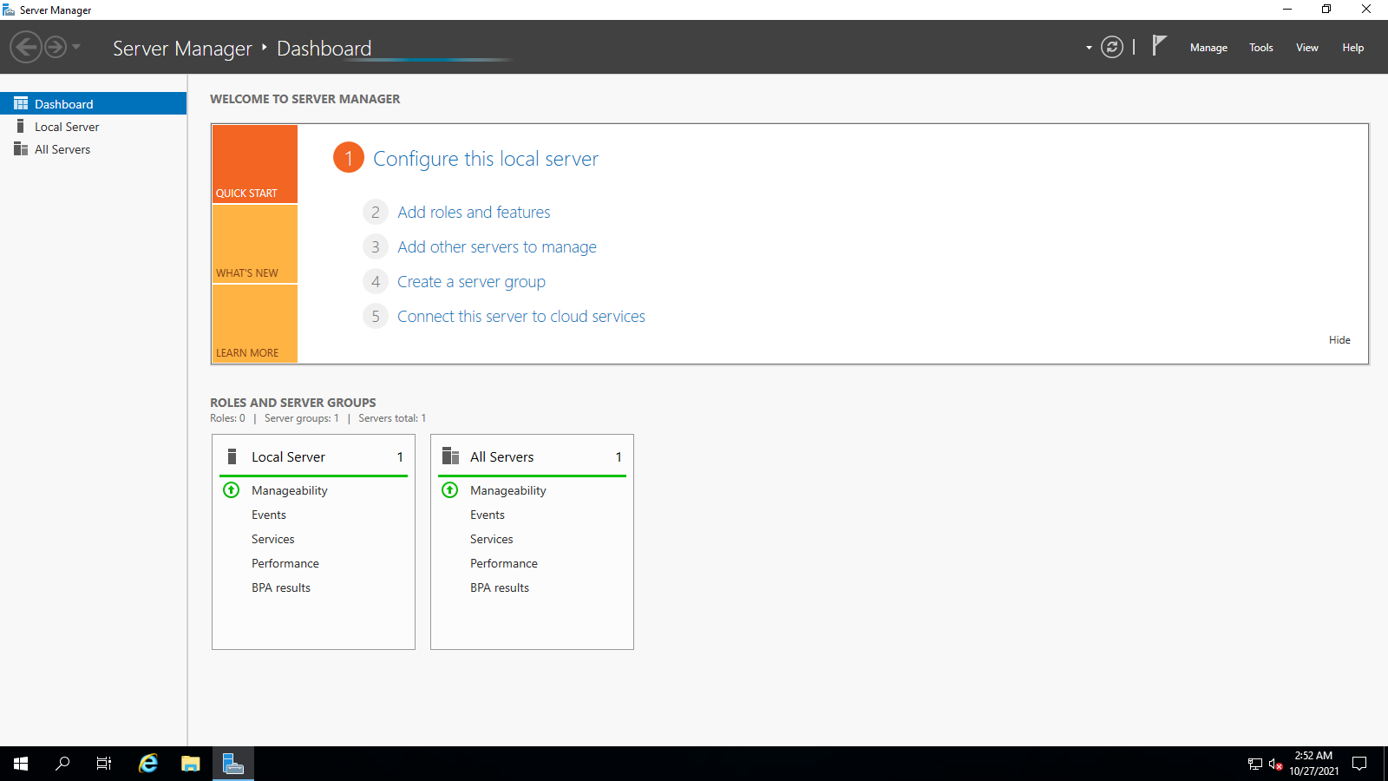

Add Role and features

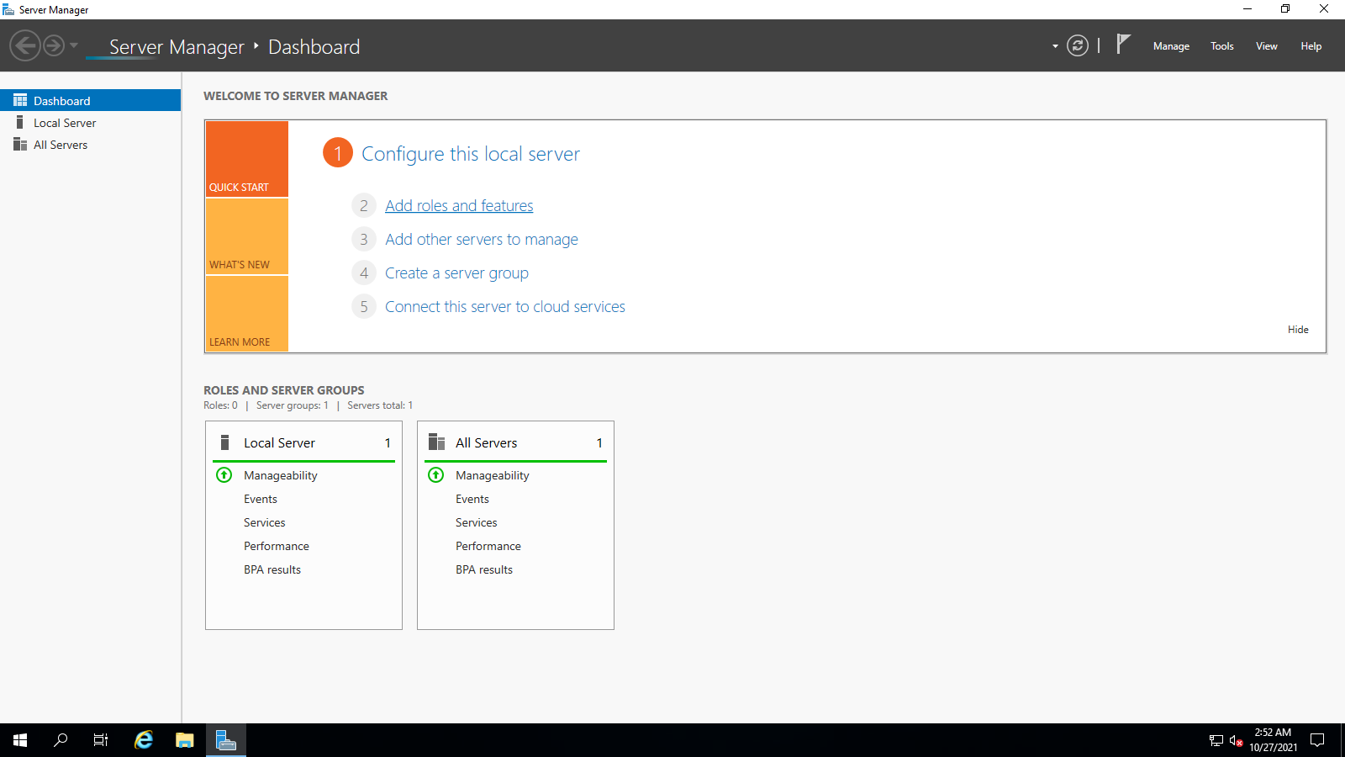

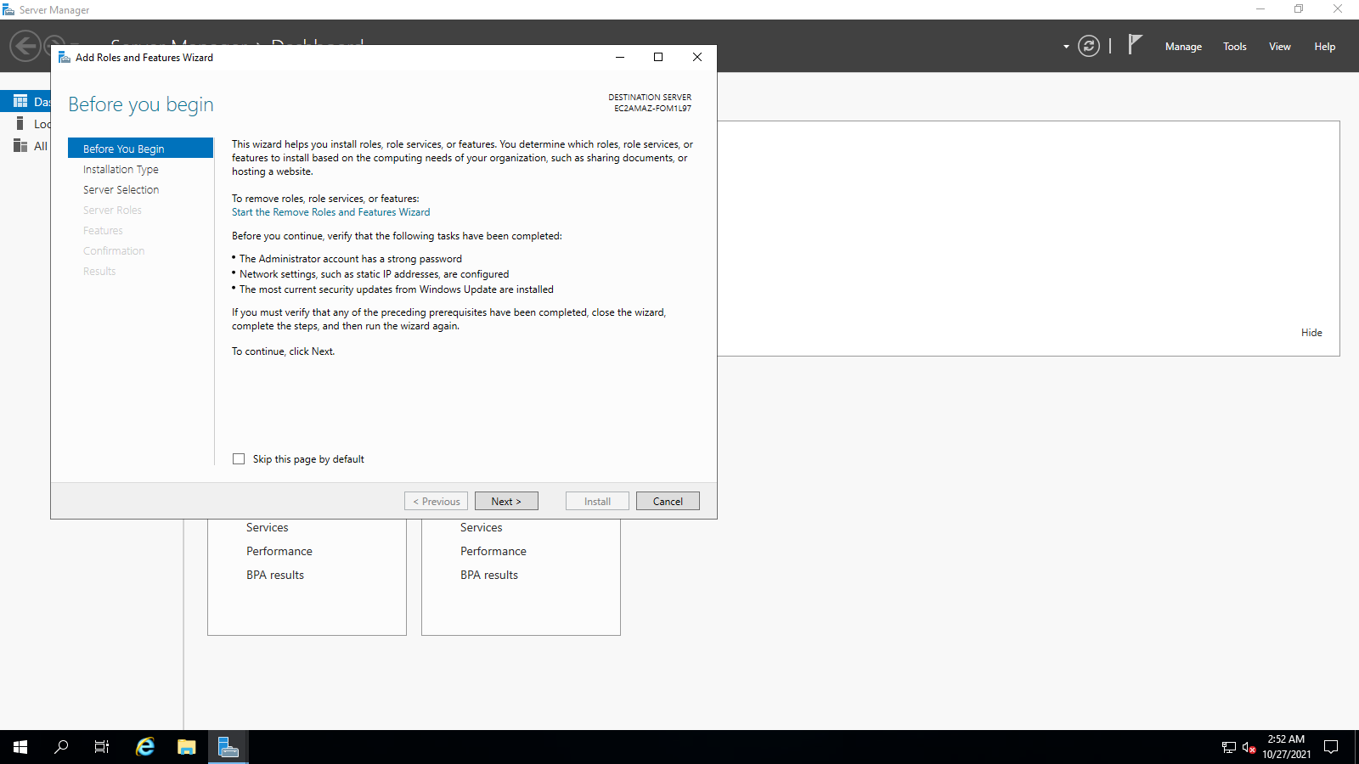

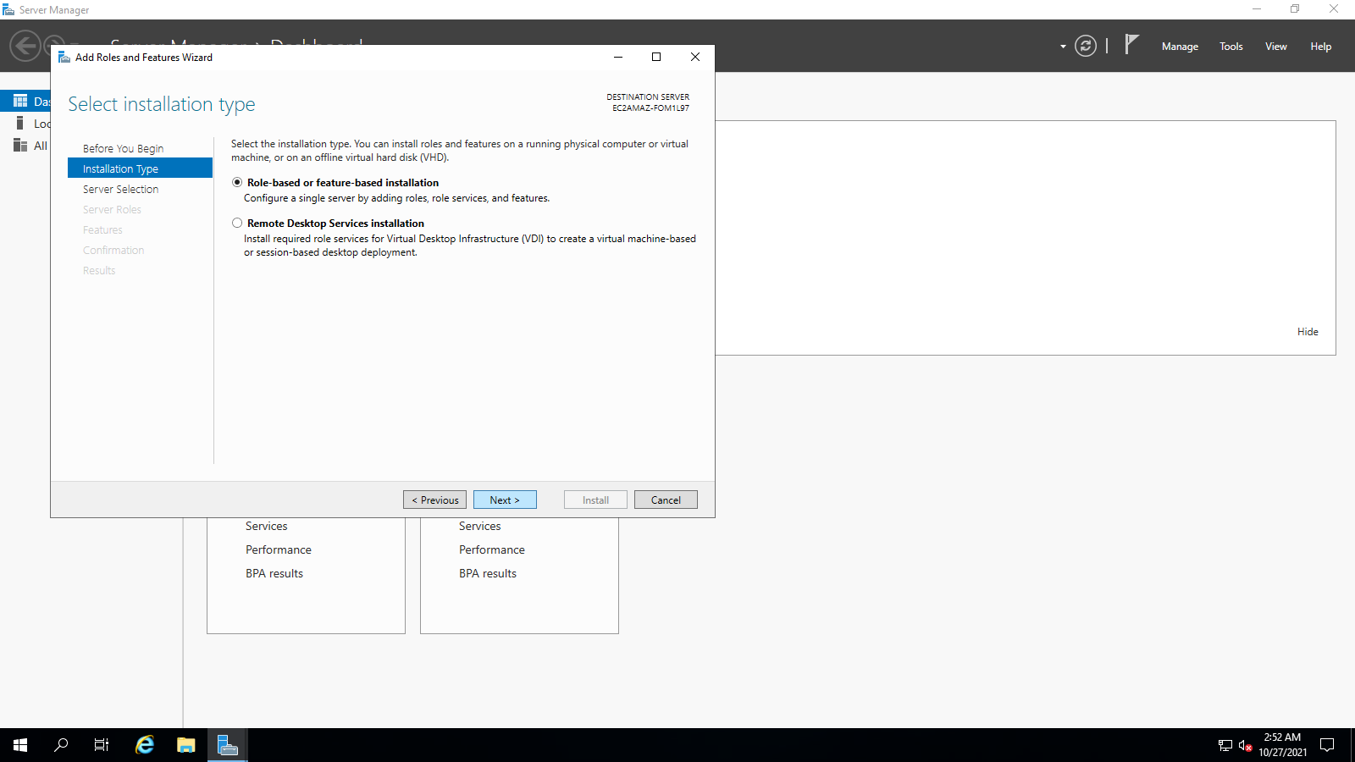

Select server 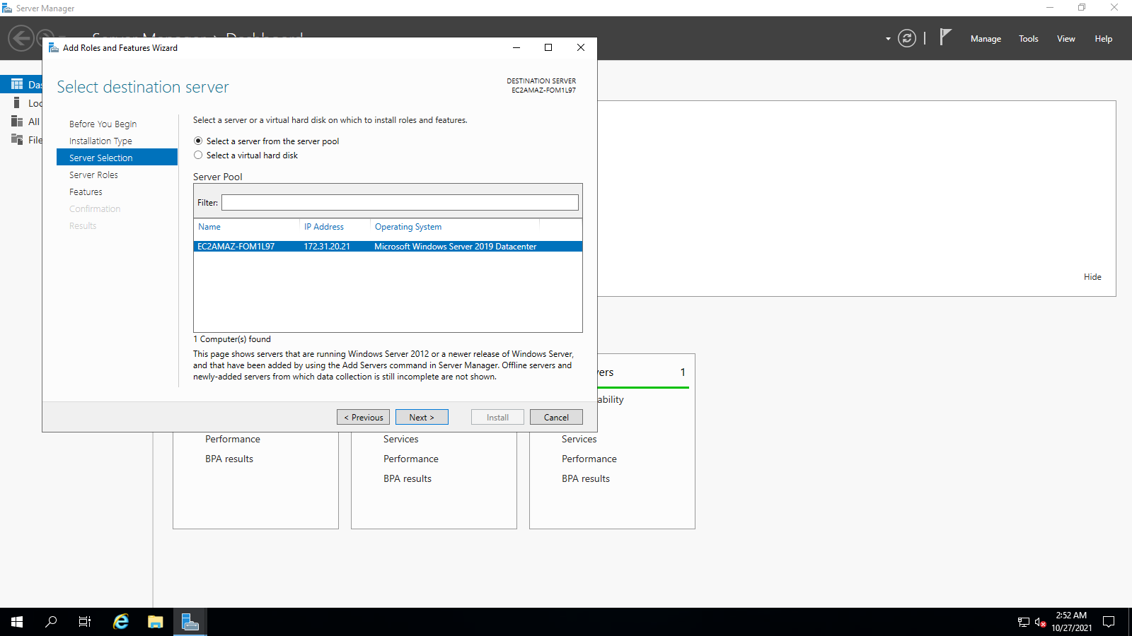

Add features **next next next next** Install

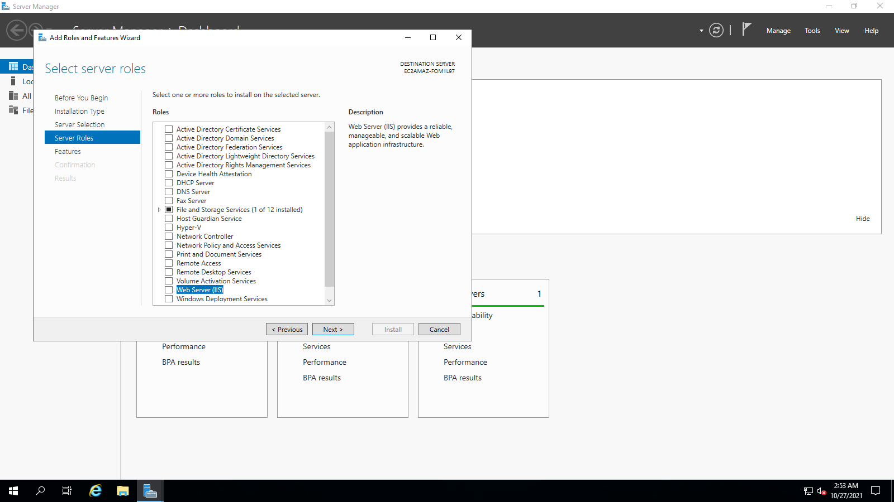

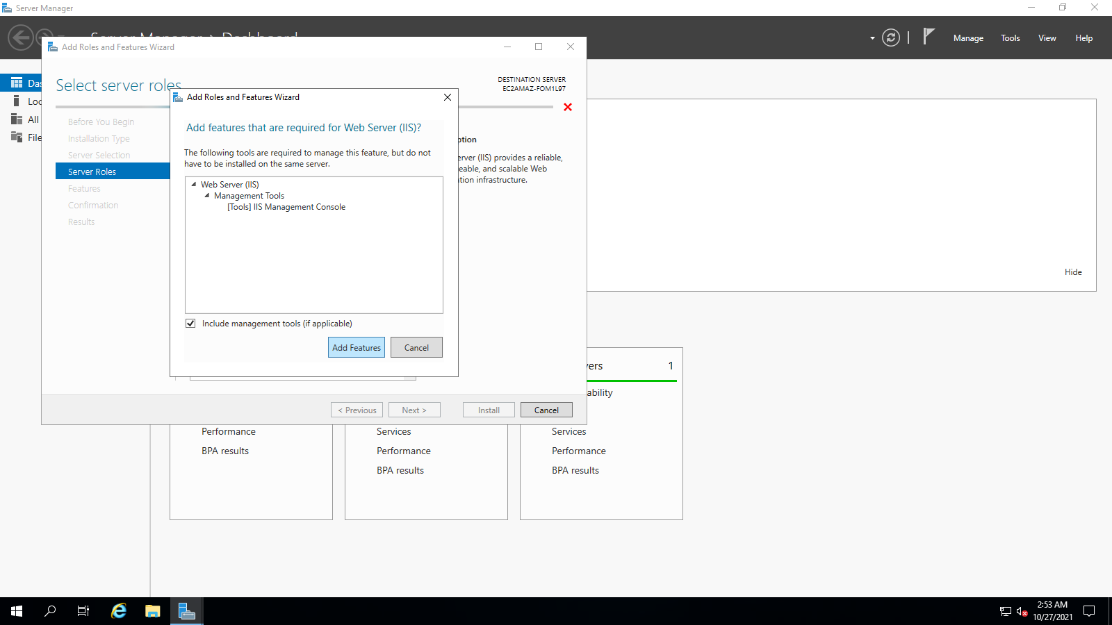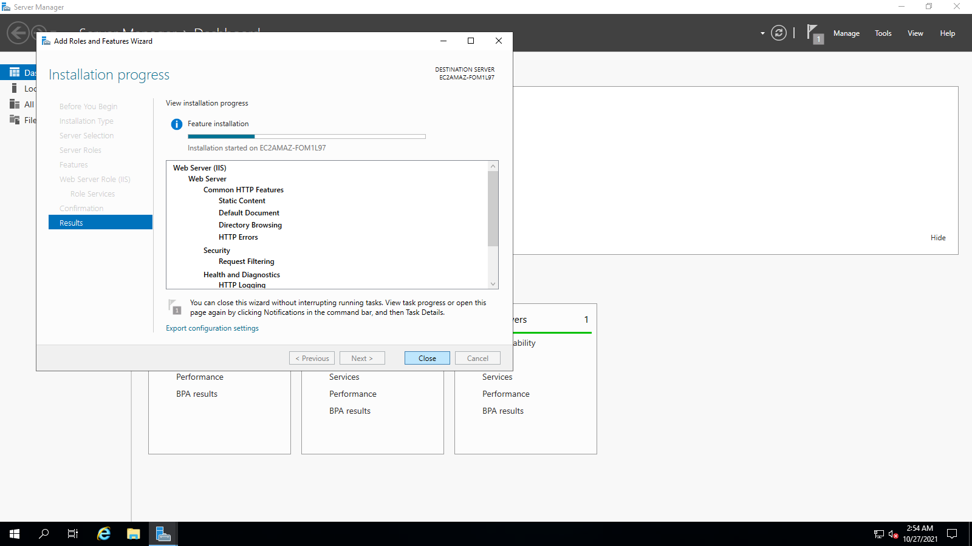

Click folder

Goto C Drive

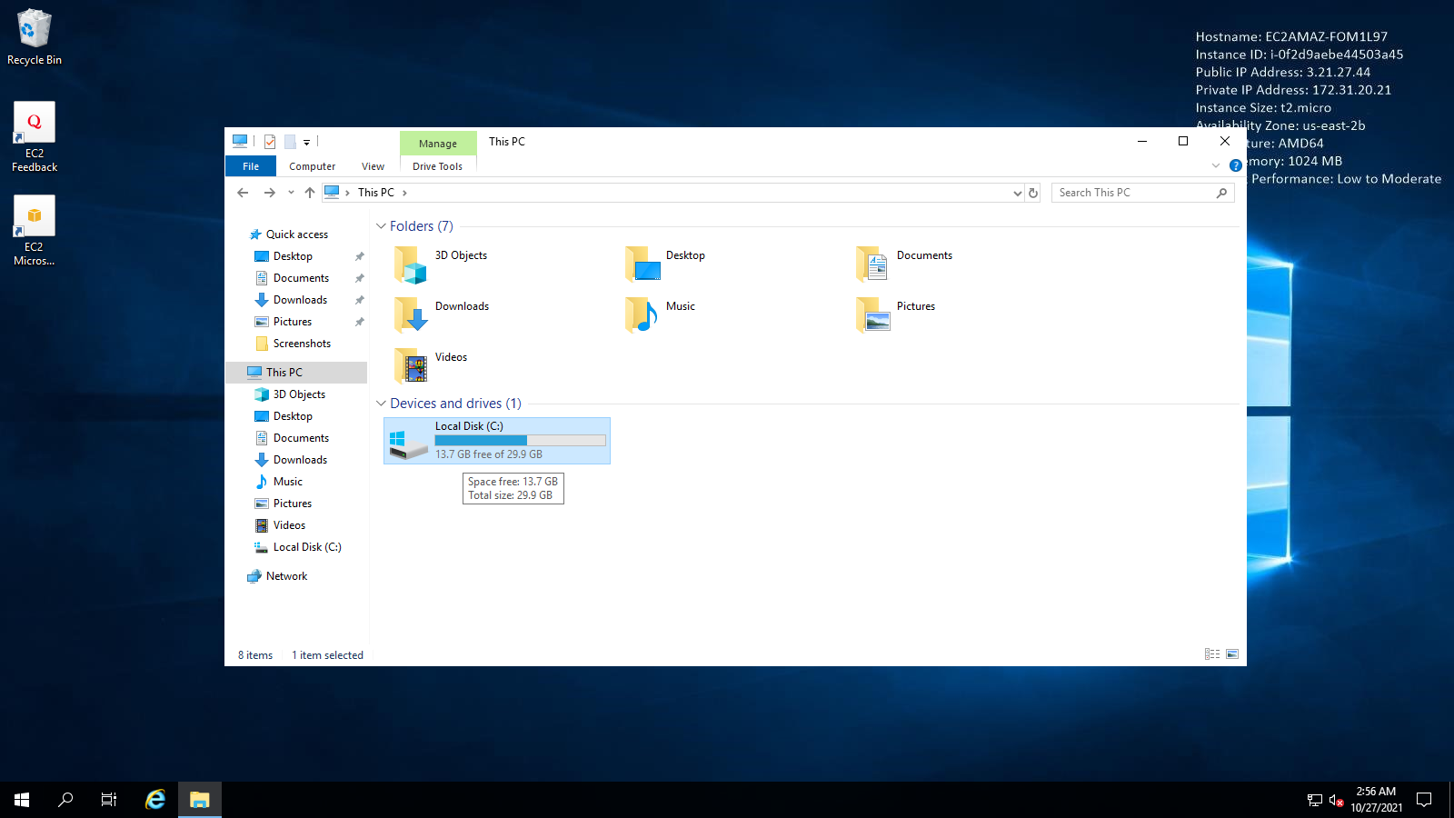

Goto C Drive inetpub 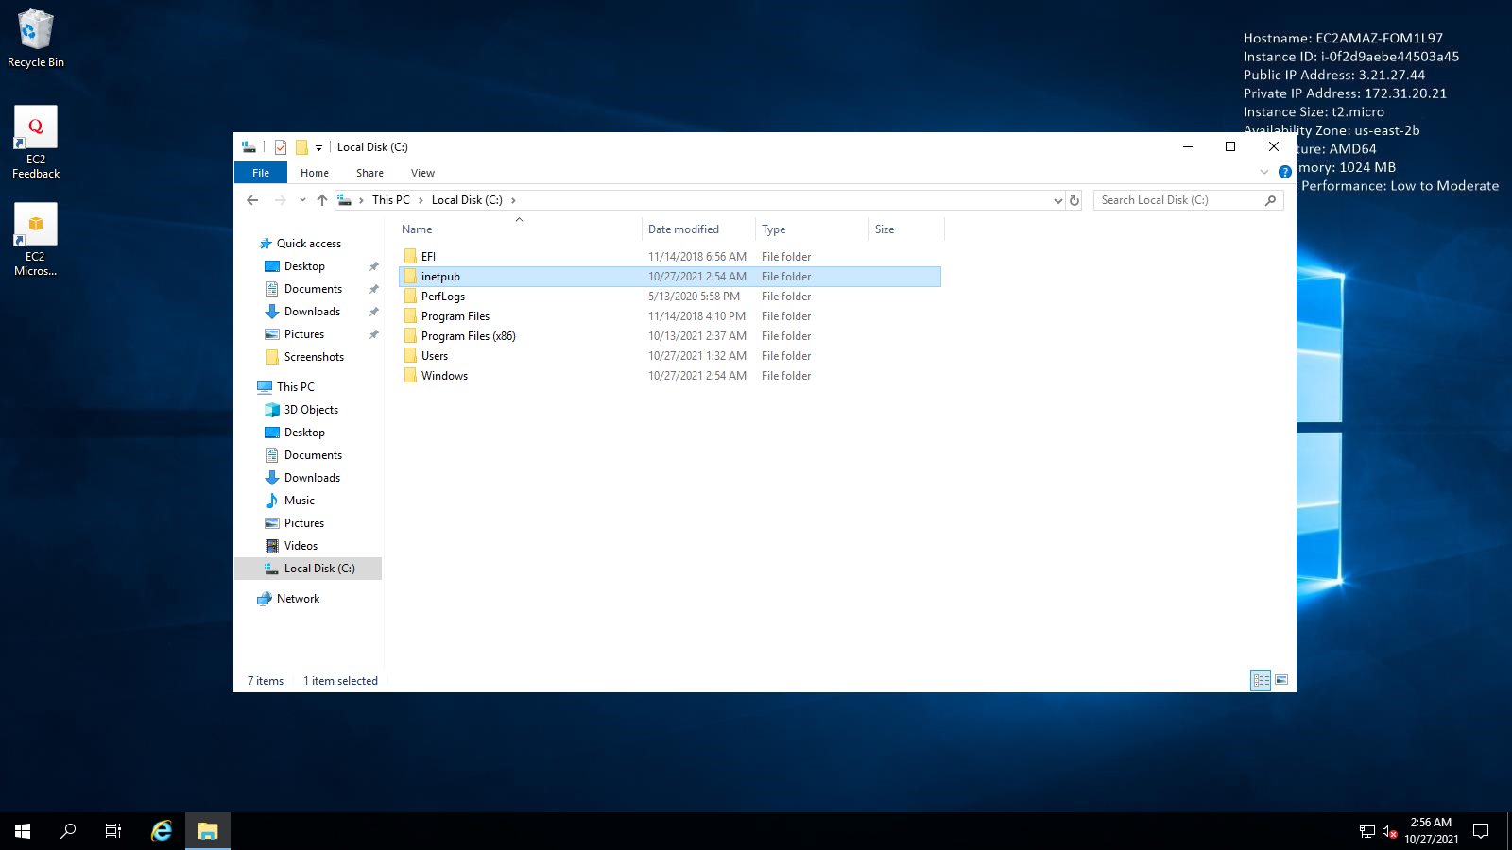

Goto wwwroot

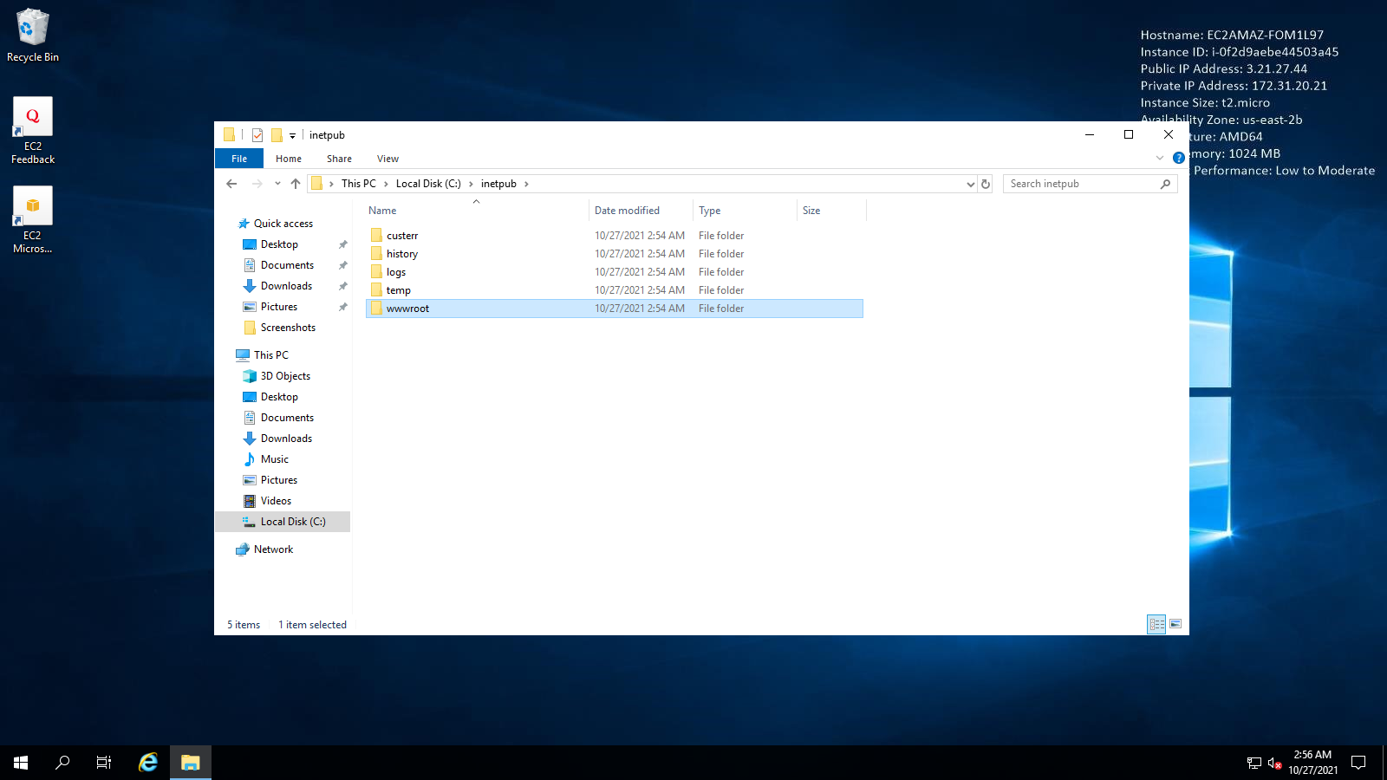

Select all and delete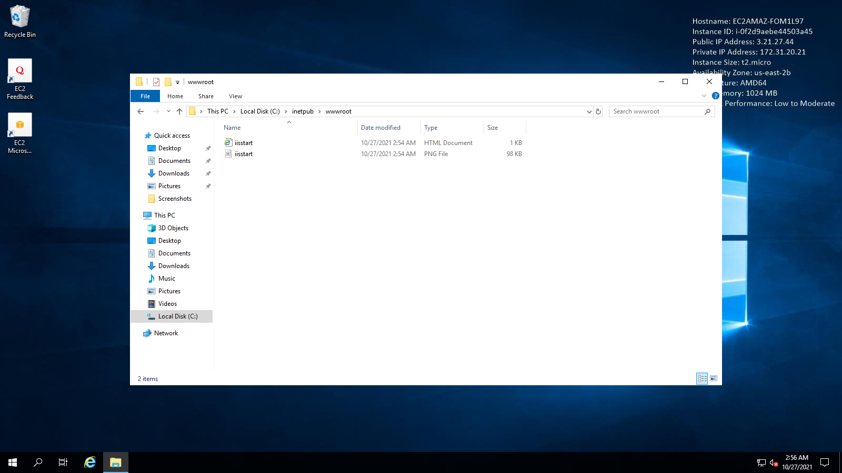

Make a new text file:

This is My First experiment with AWS.

Save as index.html

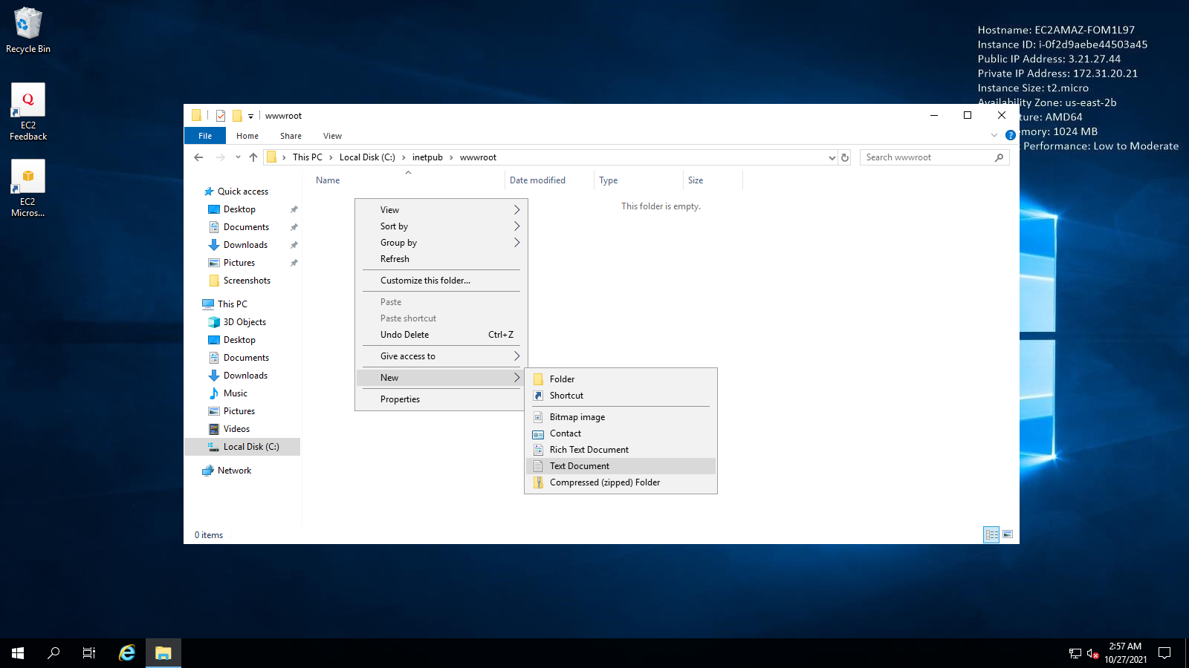

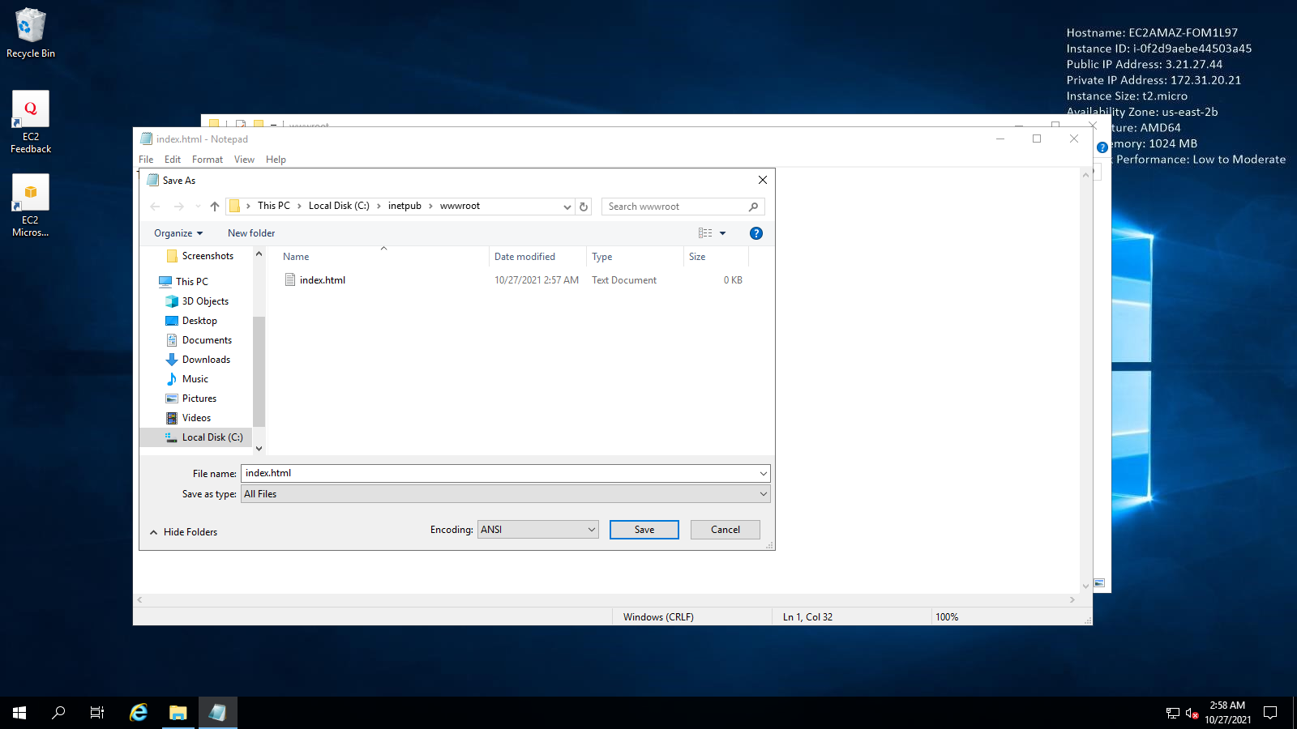

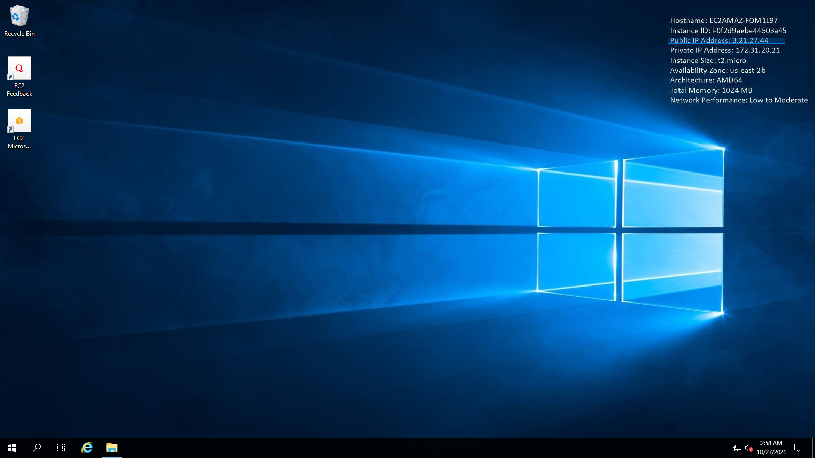

Note: The Public IP of the Machine

And open in browser from anywhere

